Introduction to Project Management
Project Management is the application of knowledge, skills, tools, and techniques to project activities in order to meet project requirements.
It ensures that a project is completed on time, within budget, and with desired quality.
A project is a temporary endeavor undertaken to create a unique product, service, or result. Unlike operations (which are ongoing), projects have a defined start and end.
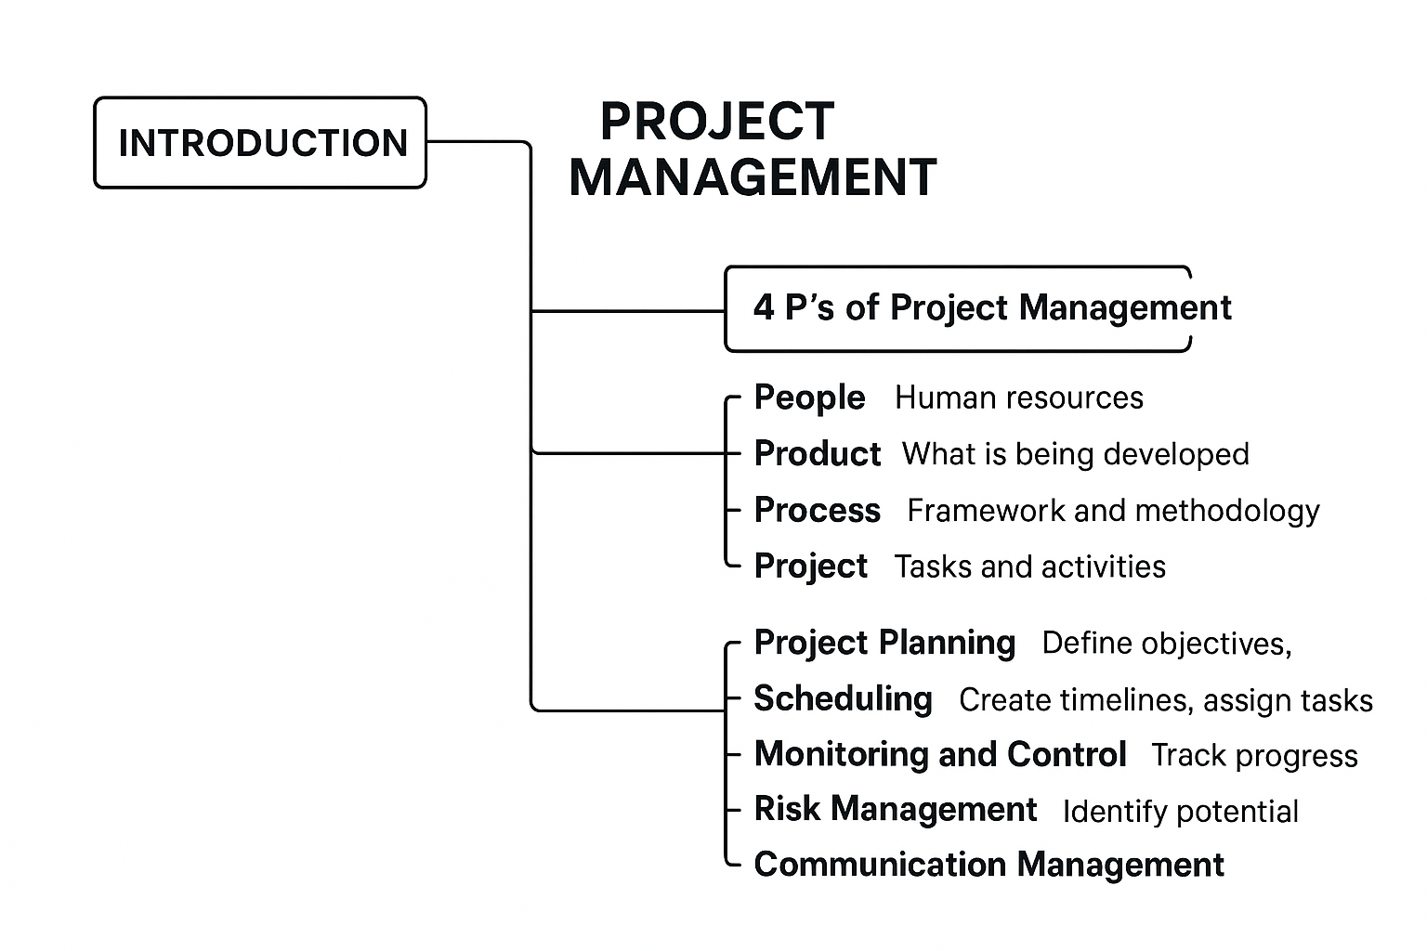
🔹 4 P’s of Project Management
The 4 P’s represent the key dimensions for successful project execution:
- People
  - Human resources are the backbone of any project.
  - Includes stakeholders, project managers, developers, testers, and clients.
  - Effective communication, motivation, and leadership are essential.
- Product
  - Refers to what is being developed (software, system, or service).
  - Involves requirements gathering, scope definition, and design.
- Process
  - The framework and methodology followed (e.g., Waterfall, Agile, Spiral).
  - Ensures structured planning, monitoring, and control.
- Project
  - The actual execution of tasks and activities.
  - Requires balancing scope, time, cost, and quality.

🔹 Project Management Activities
Project management activities ensure proper control throughout the Software Development Life Cycle (SDLC). Key activities include:
- Project Planning
  - Define objectives, scope, deliverables.
  - Develop schedules, allocate resources, estimate cost.
- Scheduling
  - Create timelines (Gantt charts, PERT charts).
  - Assign tasks to team members.
- Monitoring and Control
  - Track progress, performance, and adherence to scope.
  - Identify issues and apply corrective measures.
- Risk Management
  - Identify potential risks (technical, financial, operational).
  - Plan mitigation strategies.
- Communication Management
  - Ensure effective communication among stakeholders.
  - Regular reporting and meetings.
- Quality Management
  - Define quality standards and testing strategies.
  - Ensure final deliverables meet client expectations.
- Project Closure
  - Formal acceptance of deliverables.
  - Documentation, lessons learned, and team release.

✅ In summary:
- Introduction → Project management ensures successful delivery.
- 4 P’s → People, Product, Process, Project.
- Activities → Planning → Scheduling → Monitoring → Risk handling → Communication → Quality → Closure.
Common Tools Used in SPM:
- JIRA: Supports Agile, Scrum, and Kanban methodologies; used for issue tracking, sprint planning, and bug management.
- Microsoft Project: Offers Gantt charts, scheduling, and resource allocation; ideal for large-scale software projects.
- Trello: Visual tool using boards and cards for task management and workflow tracking.
- Asana: Used for task assignment, progress tracking, and team collaboration.
- Basecamp: Simplifies communication, file sharing, and project discussions.
- Redmine: Open-s
Benefits of Using Tools in SPM:
- Improves team collaboration and communication.
- Increases productivity and efficiency.
- Provides better project visibility and control.
- Reduces risks and ensures timely delivery.
Integration Capabilities:
These tools often integrate with other platforms like GitHub, Slack, Confluence, or Google Drive for seamless workflow management and version control.

Example Use Cases:
- A software team using JIRA to manage sprint tasks, track bugs, and generate performance reports.
- A project manager using Microsoft Project to plan timelines, allocate resources, and forecast completion dates.
- Redmine: Open-s tool for project tracking and version control integration.

Lines of Code (LOC) in Software Project Management
- Definition:
LOC (Lines of Code) refers to the total number of lines written in a program’s source code, including executable statements, declarations, and comments (depending on counting method). It is one of the oldest and simplest metrics used to measure the size and complexity of a software project.
- Purpose:
LOC is primarily used to estimate the effort, cost, and productivity in software development. It helps project managers in models like COCOMO to predict how much time and manpower will be required to develop a system.
- Types of LOC:
  - Physical LOC: Counts every line in the source code file, including blank lines and comments.
  - Logical LOC: Counts only executable and meaningful statements that affect the program’s behavior.( Excluding blank lines and comments.)

- Formula in Estimation Models:
In the COCOMO model, project size is expressed in KLOC (Kilo Lines of Code), where:
$$1\text{ KLOC}=1000\text{ Lines of Code}$$
Example: If a project has 25,000 lines of code, then it equals 25 KLOC.
- Example 1:
Suppose a simple payroll system consists of 10,000 lines of code (10 KLOC). Using the COCOMO Organic mode formula:
$$\text{Effort (E)}=2.4×(10)^{1.05}=27.1\text{ person-months}$$
This means approximately 27 person-months of effort are required to develop the system.
- Example 2:
For a large embedded project with 50,000 LOC (50 KLOC),
$$\text{Effort (E)}=3.6×(50)^{1.20}=275\text{ person-months}$$
Thus, larger projects with higher LOC values demand significantly more effort and time.
- Advantages of LOC Metric:
  - Easy to understand and calculate.
  - Provides a direct measure of project size for estimation models.
  - Useful for productivity measurement (e.g., LOC per person-month).
- Limitations:
  - Not suitable for comparing projects across different programming languages (since LOC varies).
  - Encourages writing more code rather than efficient code.
  - Does not account for code quality, complexity, or functionality.
  - Difficult to estimate accurately in the early stages of a project.
- Applications:
  - Used in cost estimation models like COCOMO.
  - Helps in productivity analysis (e.g., lines of code produced per developer per month).
  - Used for maintenance estimation and defect density measurement.
- Conclusion:
LOC remains a fundamental software metric in project management. Although modern techniques like Function Points or Use Case Points are often preferred, LOC is still valuable for estimating effort, cost, and size in traditional software projects, especially when combined with models like COCOMO.

SRS

Software Requirements Specification (SRS) – In Detail
A Software Requirements Specification (SRS) is a comprehensive document that defines the purpose, features, functionalities, and constraints of a software system. It acts as a bridge between the client’s requirements and the developer’s implementation. The SRS provides a complete description of how the software will perform from the user’s perspective and specifies what the system must do — not how it will do it. It ensures that all stakeholders (clients, developers, testers, and project managers) share a clear and common understanding of the project requirements before actual development begins. The main objectives of an SRS are to eliminate ambiguity, serve as a basis for system design and testing, and act as a reference document during maintenance or future upgrades.
A well-structured SRS generally consists of several key sections:
- Introduction – Defines the purpose, scope, and objectives of the software system.
- Overall Description – Gives a general view of the product, its functions, users, and constraints.
- Functional Requirements – Lists detailed operations or services the system must perform.
- Non-functional Requirements – Specifies performance, reliability, scalability, and usability standards.
- System Features – Describes specific modules or functions with detailed input/output details.
- External Interface Requirements – Defines how the software interacts with hardware, other systems, and users.
- Constraints and Assumptions – Lists system limitations, dependencies, or specific design conditions.

Example of a Detailed SRS – Online Library Management System
1. Introduction
The purpose of this system is to automate the management of library activities like issuing, returning, and tracking books. It reduces manual work, improves record accuracy, and enhances user convenience.
2. Scope
The system will allow students and staff to search, borrow, and return books online. The administrator can manage books, view reports, and monitor user activity.
3. Functional Requirements
- FR1: The system shall allow users to register with unique login credentials.
- FR2: The system shall enable users to search books by title, author, or category.
- FR3: The system shall allow the librarian to issue and return books, updating the database automatically.
- FR4: The system shall send due date reminders via email to users.
4. Non-Functional Requirements
- NFR1 (Performance): The system shall process book search requests within 2 seconds.
- NFR2 (Security): All user passwords shall be stored in encrypted format.
- NFR3 (Availability): The system shall be available 99.5% of the time except during scheduled maintenance.
- NFR4 (Scalability): The database shall support up to 50,000 books and 10,000 users concurrently.
5. External Interface Requirements
- The system shall support web browsers like Chrome, Firefox, and Edge.
- The database used shall be MySQL, connected through a secure API interface.
6. Constraints
- The application must run on Windows and Linux operating systems.
- Development must be completed within four months using the Python-Django framework.

Additional Real-Life SRS Examples
Example 1: Student Management System
- Functional Requirement: The system shall allow the admin to add, update, and delete student details such as name, roll number, and marks.
- Non-functional Requirement: The system shall generate a student report card within 5 seconds and store it securely in the database.
This ensures quick and efficient management of student data while maintaining system reliability and speed.
Example 2: Online Food Ordering System
- Functional Requirement: The system shall allow users to browse restaurant menus, select food items, and place orders online.
- Non-functional Requirement: The system shall handle up to 1000 concurrent users and ensure that order confirmations are sent within 2 seconds.
This ensures the system performs efficiently even during high-traffic periods, providing a smooth user experience.

https://krazytech.com/projects/sample-software-requirements-specificationsrs-report-airline-database

Software Project Planning (SPP) – In Detail
Software Project Planning (SPP) is the process of defining the objectives, scope, resources, schedule, and activities required to successfully complete a software project. It is one of the most crucial phases of the Software Project Management (SPM) process, as it lays the foundation for all subsequent project activities. The primary goal of project planning is to create a structured roadmap that ensures the project is completed on time, within budget, and meets quality standards. It involves identifying what needs to be done, how it will be done, who will do it, and when it will be done. Effective planning minimizes project risks, avoids cost overruns, and ensures smooth coordination between team members.
The key components of Software Project Planning include:
- Project Scope Definition: Clearly outlines the boundaries and deliverables of the project.
- Objective Setting: Specifies measurable and achievable goals for the software product.
- Effort and Cost Estimation: Uses models like COCOMO, Function Point Analysis (FPA), or Expert Judgment to estimate manpower and financial requirements.
- Scheduling: Defines the project timeline using tools like Gantt Charts, PERT Charts, or Critical Path Method (CPM).
- Resource Allocation: Assigns human, technical, and financial resources for each task.
- Risk Management: Identifies potential risks, analyzes their impact, and plans mitigation strategies.
- Communication and Quality Plan: Ensures proper coordination among stakeholders and maintains quality throughout development.

Phases of Software Project Planning
- Preliminary Planning: Involves feasibility analysis and defining project goals and deliverables.
- Detailed Planning: In this phase, detailed schedules, task dependencies, and resource requirements are defined.
- Execution Planning: Defines how development, testing, and deployment will be executed according to the schedule.
- Monitoring and Control: Ensures the project stays on track through periodic reviews and performance evaluation.

Example 1: Online Shopping Application
Suppose a company plans to develop an Online Shopping App. During project planning:
- Scope: The app should allow users to browse products, add items to a cart, and make secure payments.
- Objectives: Deliver a bug-free application within 6 months.
- Estimation: Using the COCOMO model, the effort is estimated at 50 person-months with a budget of ₹10 lakhs.
- Schedule: The project is divided into modules — UI design (1 month), backend development (3 months), testing (1 month), and deployment (1 month).
- Risks: Potential risks include payment gateway failure, integration issues, and time overruns, so contingency plans are made to handle them.
This ensures that all team members understand their roles, timelines, and deliverables, resulting in smooth execution and on-time delivery.

Example 2: Hospital Management System
In planning a Hospital Management System, project planning would involve:
- Scope: Automate patient registration, billing, and appointment management.
- Objective: To reduce manual errors and improve patient service efficiency.
- Resource Allocation: Assign 2 developers for front-end design, 3 for back-end database, and 1 for testing.
- Scheduling: Using a Gantt chart, tasks are sequenced — requirement analysis (2 weeks), system design (3 weeks), coding (8 weeks), testing (4 weeks), deployment (2 weeks).
- Risk Planning: Includes potential risks such as data security breaches or delays due to system integration.
Proper scheduling, cost estimation, and risk control ensure that the hospital management system is developed efficiently and within the planned time frame.

